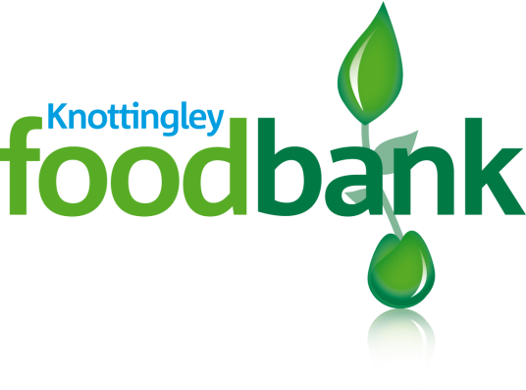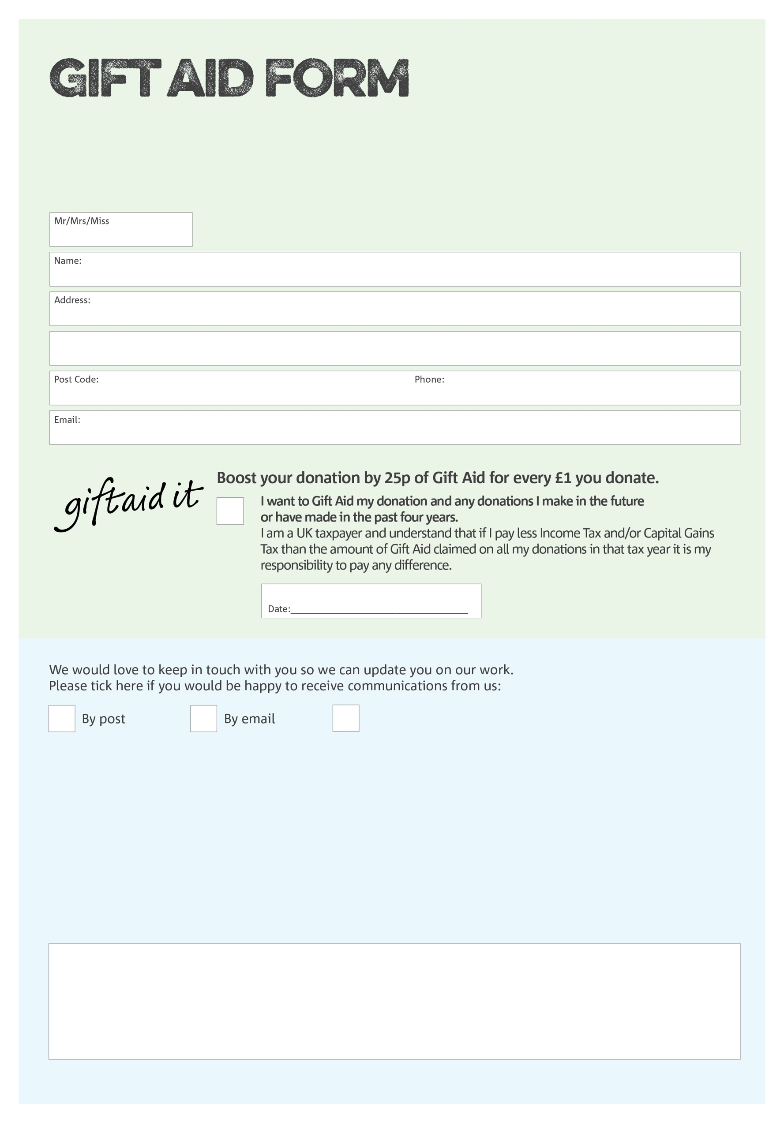

By filling in this form Knottingley Foodbank will receive an extra 25p for every £1 you give at no extra cost to you. Thank you!

Address: Knottingley Foodbank, Knottingley Community Church, Tithe Barn Rd, Knottingley, WF11 9BU

Charity Number 1163711. Registered in England & Wales

**Data protection**

*'Knottingley Foodbank is committed to protecting your privacy and will process your personal data in accordance with current Data Protection legislation. Knottingley Foodbank collects information to keep in touch with you and supply you with information relating to our work. To unsubscribe from our newsletter, send a message to the email address above with the word unsubscribe in the subject line. A full data privacy statement for financial donors is available from the foodbank on request.’*

You can change your preferences any time by contacting us on 07581 188 614 or emailing us at

info@knottingley.foodbank.org.uk

I do not wish to receive future communications from Knottingley Foodbank

We would love to know why you have chosen to donate to Knottingley Foodbank. If you would like to share your motivation let us know below: